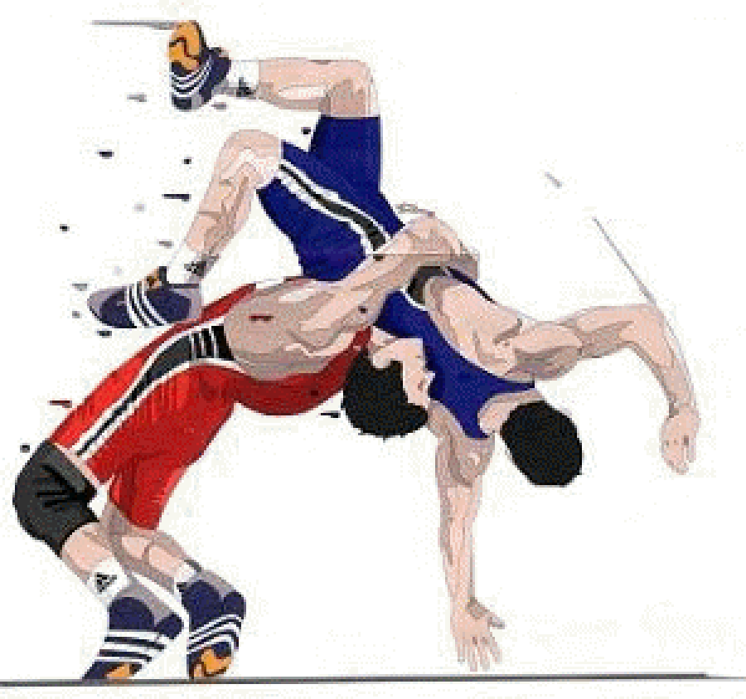 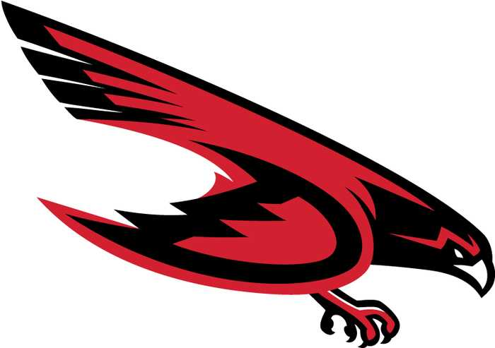

**2024 DUNEDIN FALCONS**

**Varsity Wrestling Schedule**

**HEAD COACH: COLIN GRANTHAM**

|  |  |  |  |
| --- | --- | --- | --- |
| **Date** | **Home/Away** | **Opponent** | **Event Location** |
| 12/6/2024 | AWAY | IBT WEEKI WACHEE | WEEKI WACHEE |
| 12/13-14/2024 | AWAY | FIT 2 WIN | PHUHS |
| 12/20/2024 | AWAY | SOUTHSIDE DUALS | BOCA CIEGA |
| 1/4/2025 | AWAY | GEORGE JENKINS DUALS | GEORGE JENKINS |
| 01/6-9/2025 | TBD | DISTRICT DUALS | TBD |
| 1/10/2025 | HOME | FALCON DUALS | DUNEDIN |
| 1/14/2025 | HOME | WEEKI WACHEE | DUNEDIN |
| 1/13-17/2025 | TBD | REGIONAL DUALS | TBD |
| 1/17-18/2025 | AWAY | JERRY MITA INVITATIONAL | PINELLAS PARK |
| 1/24-25/2025 | AWAY | STATE DUALS | OSCEOLA KISSIMMEE |
| 1/24/2025 | AWAY | GULF DUALS | GULF HIGHS SCHOOL |
| 1/28/2025 | HOME | SENIOR NIGHT | DUNEDIN |
| 2/7-8/20252/ | AWAY | BRANDON | BRANDON |
| 2/15/2025 | AWAY | OSCEOLA | PCAC |
| 2/22/2025 | AWAY | DISTRICTS | TBD |
| 2/28-3/1/2025 | AWAY | REGIONAL | LEMON BAY |
| 3/7-9/2025 | AWAY | STATES | SILVER SPURS KISSIMMEE |